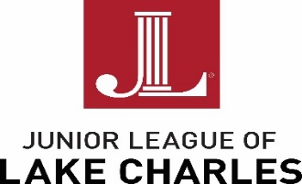

January 16, 2020

Lexi Paret and Caroline Hennigan
Grants and Programs
Junior League of Lake Charles, Inc.
1019 Lakeshore Drive
Lake Charles, LA 70601-9428

Re: 2019-2020 Community Alliance Program

I am pleased to provide you with information about the Junior League of Lake Charles, Inc.’s (JLLC) Community Alliance Program (CAP).

CAP assists non-profit agencies in Lake Charles with specific, short-term monetary needs. All grants awarded shall be used for projects that benefit the community and represent the League’s commitment to our vision; therefore, grants are awarded only in the following areas:

JLLC chooses projects that meet the guidelines set forth by our bylaws and policies and are focused on helping to fulfill JLLC’s mission statement:
The Junior League of Lake Charles, Inc., is an organization of women committed to promoting voluntarism, developing the potential of women and improving the community through the effective action and leadership of trained volunteers. Its purpose is exclusively educational and charitable.

Grant requests may be made for up to $5000 and may also include a request for volunteer hours from the JLLC. Two grants will be presented this league year – the CAP Award and the Legacy CAP Award. The Legacy CAP Award is eligible only to those associated with the League’s legacy programs. No restrictions are placed on the CAP Award and all non-profit organizations are eligible to apply.

For application and project proposal details, please carefully review all of the information included in the grant proposal packet. You can also access information and download the grant application online at www.jllc.net.

Applications must be emailed to JLLC at grants_scholarships@jllc.net by Monday, March 9, 2020 for consideration. If you need help or have questions about the application process, please contact us via email or through the JLLC Headquarters at 337-436-4025.

Thank you for all that you do to make a difference in our community!
Sincerely,

Shellie Eskew Lexi Paret and Caroline Hennigan
2019-2020 President 2019-2020 Grants and Programs

Community Alliance Program (CAP) Grant
Grant Deadline: March 9, 2020
Application Process Overview

Step 1: Eligibility - Determine if your organization’s efforts correspond with the JLLC’s Mission Statement:
The Junior League of Lake Charles, Inc., is an organization of women committed to promoting voluntarism, developing the potential of women and improving the community through the effective action and leadership of trained volunteers. Its purpose is exclusively educational and charitable.
*Eligible organizations must be 501(c)(3).
**Schools are not eligible to apply for this grant, because the JLLC offers a separate grant opportunity specifically for local schools every fall.
***JLLC legacy projects are eligible.

Step 2: Submit Proposal - A representative from your organization will need to submit an application for funding by the stated deadline.
Please complete all fields on the form.
Please copy your completed form if you would like a copy for your records.
Please be prepared to upload the following items:
- Line Item Budget
- IRS 501(c)(3) Determination Letter
- IRS 990 Form
- IRS W-9 Form
- Organization’s Board of Directors
- Annual Board Approved Budget

Step 3: Post Grant Reporting – Applicants, awarded a grant, must submit a Post Grant Evaluation.
This will provide JLLC with specifics on how the grant funds are used. The evaluation can be submitted via email and it should include the following:
- Name of Organization
- Contact
- Title
- Email
- Phone
- Amount of Award
- Date of Award
- Please provide brief overview of the funded project, include specifics on fund usage.
  - Funds may NOT be used for:
    - Salary support
    - Food and beverage
- What methods did you use to evaluate the success of your program/project? Did you achieve the intended goals and outcomes of your program/project?
- How many people were impacted by your program/project?
- How did your program/project help to achieve the Junior League’s vision to “enhance the quality of life in the LC community in the areas of physical health, education, and cultural development?”
- How will grant funding be publicly promoted for the organization and the JLLC?
- Pictures (if possible)

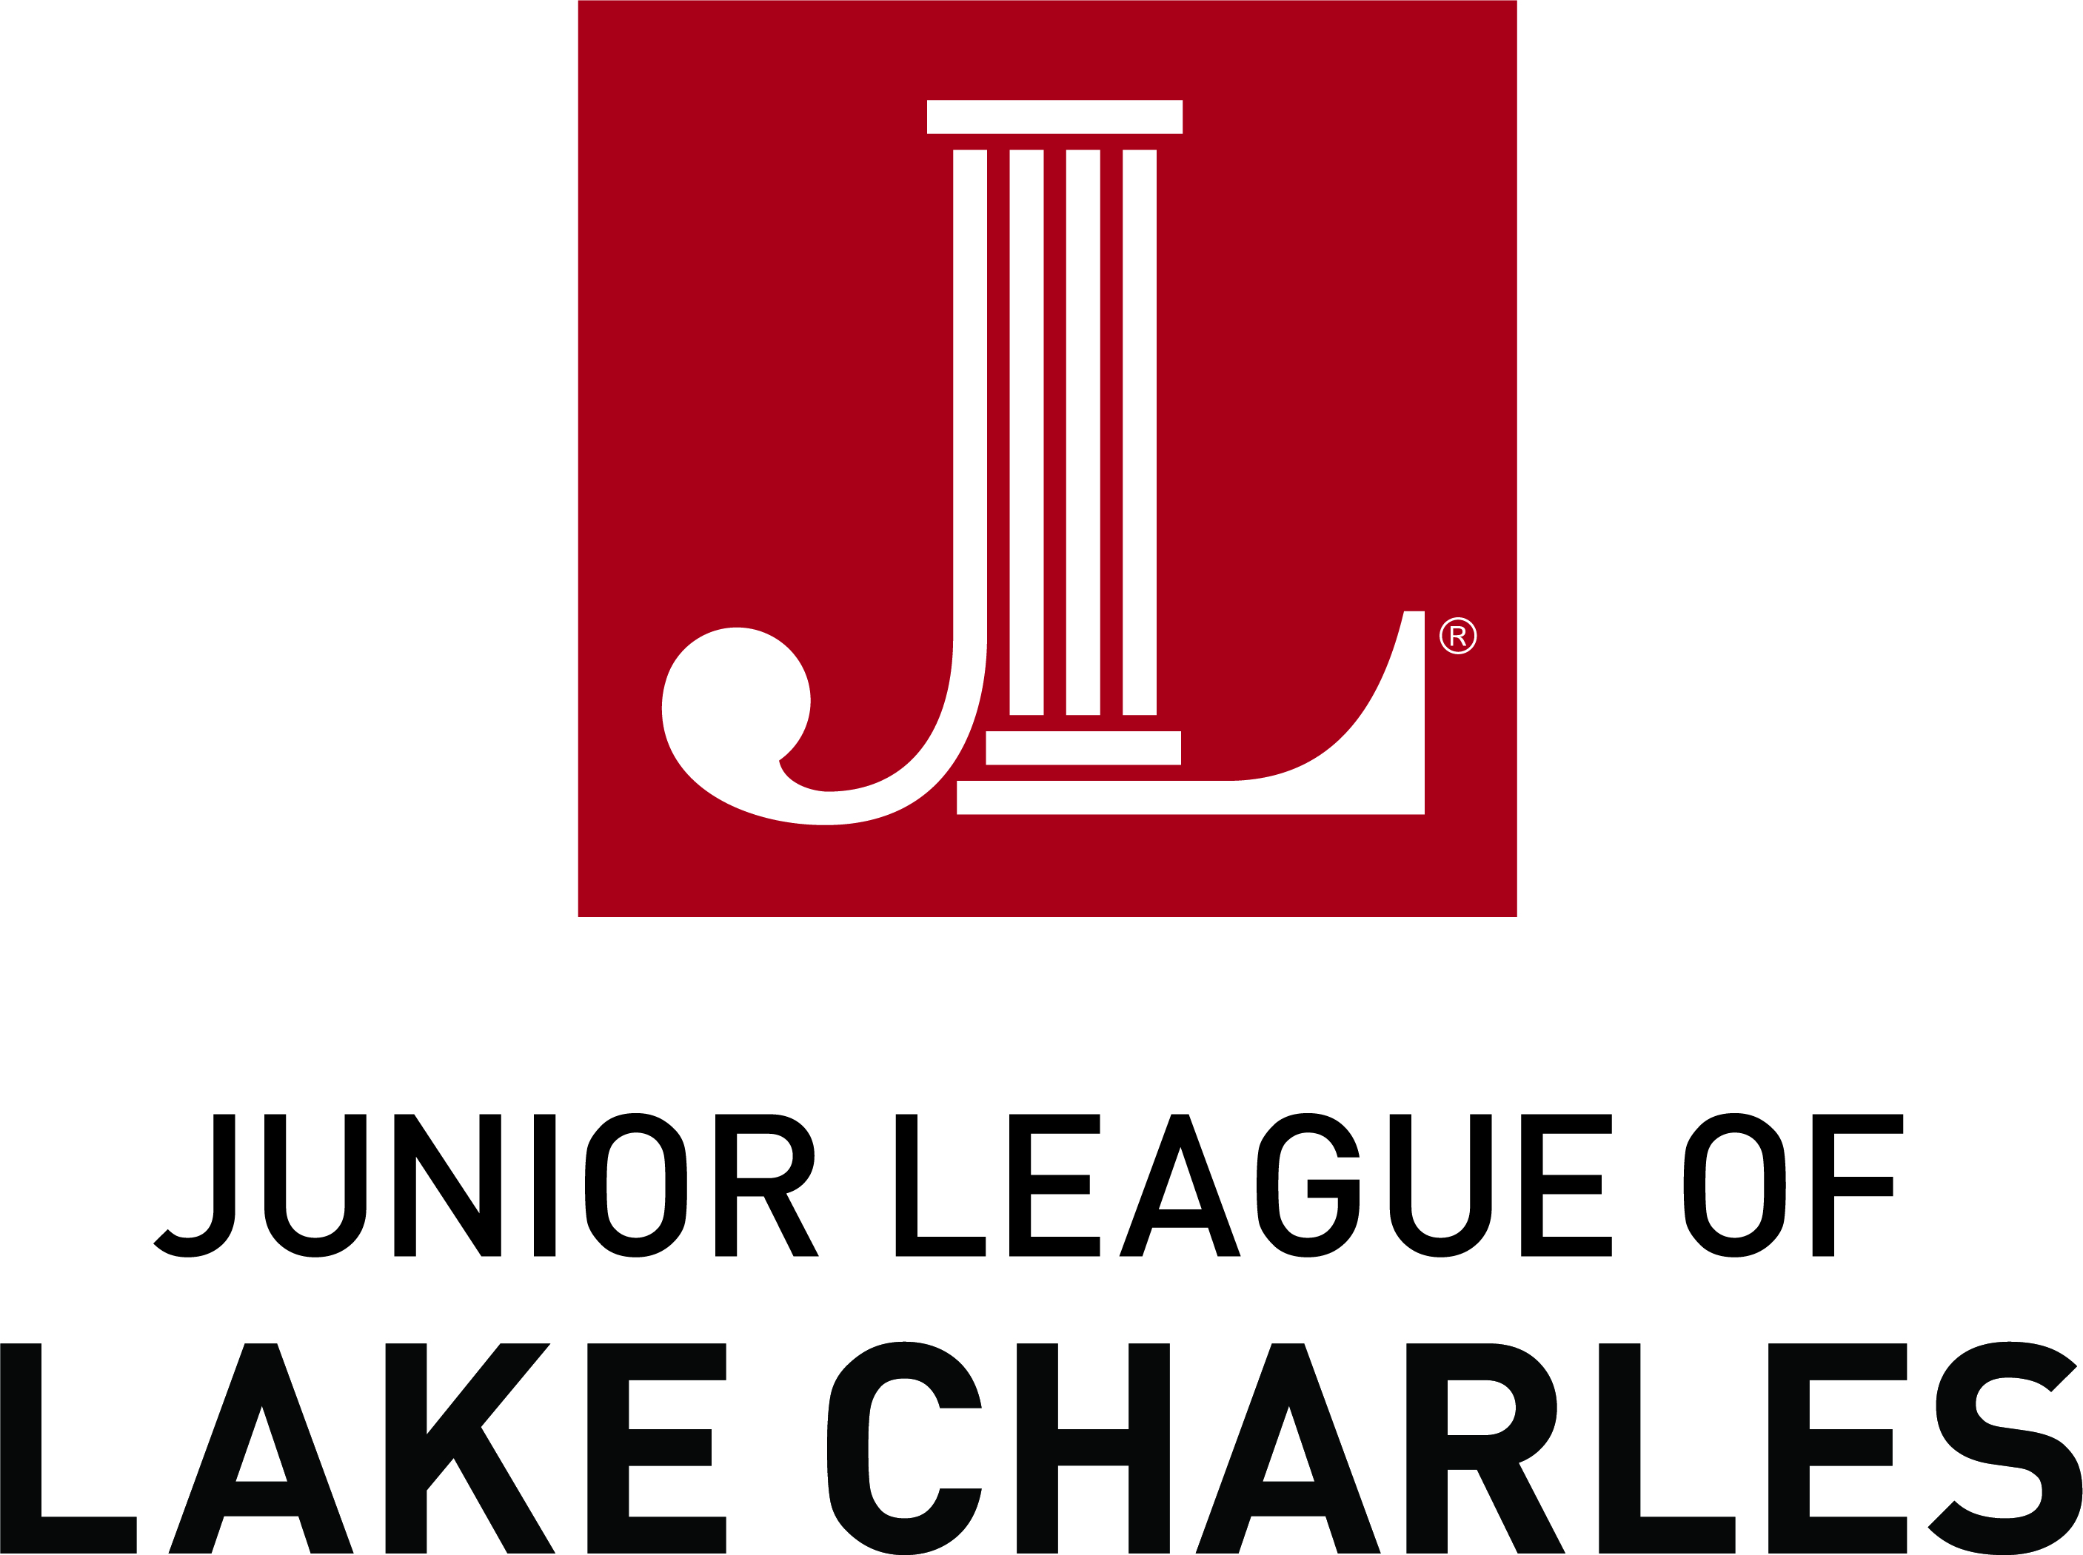
A member of The Association of
Junior Leagues International Inc.

JLLC Application number: ___________

Community Alliance Program (CAP) Grant
Grant Deadline: March 9, 2020

□ Check box if a legacy program of the JLLC. Have you received JLLC funds in the last 3 years? _____

Organizational Information
Name of Organization: _______________________________________________________________
Federal Tax Identification Number (EIN): _________________________________________________
Data and Place of Incorporation: ________________________________________________________
Organization Address: ________________________________________________________________
Organization Phone: __________________________________________________________________
Organization Website: ________________________________________________________________

Contact Information
Contact Person: _____________________________________________________________________
Title: ______________________________________________________________________________
Contact Address: ____________________________________________________________________
Contact Phone: ______________________________________________________________________
Contact Email: ______________________________________________________________________

OVERVIEW
Project Name: _________________________________________________________________
Amount Requested in this proposal: ______________________ # People Impacted _____

By affixing my signature, I certify and agree to the following:
1. If I am awarded a grant, the money granted will be spent to support only the above project. Any money not utilized for this grant will be returned to the Junior League of Lake Charles, Inc.
2. Upon completion of any funded project, I will provide the Junior League of Lake Charles, Inc., with a brief written report describing the project and benefits to students, together with photographs if available.
3. Any promotional materials, press releases, or other media produced in connection with or to publicize the funded project will note that it was funded in part or sponsored by the Junior League of Lake Charles, Inc.
4. A record of all expenditures, together with copies of legible receipts, will be maintained and submitted to the Junior League of Lake Charles, Inc., on the appropriate forms by July 31, 2020, unless an extension is granted by prior mutual agreement. If records are not received, recipients will not be eligible for future CAP grant funding.
5. The Junior League of Lake Charles, Inc., may use information regarding this project for publicity purposes.
Signature of Contact: ____________________________ Date: ________________

JLLC Application number: ________________

Community Alliance Program (CAP) Grant
Grant Deadline: March 9, 2020

Grant selection is blind; please do not include your name or other identifying information in the body of the application. This information should be included only on the attached cover sheet.

Applications must be typed and completed in full. Handwritten, illegible or incomplete applications will not be considered.

PROPOSAL SUBMISSION – ESSAY
In 300 words or less, please give an overview of the project for which you are requesting funding.
Please indicate your proposal’s area of impact and how it aids the JLLC’s mission.
ORGANIZATION BACKGROUND
- History, Mission, goals and background of organization (including date founded)
- Have you previously applied for JLLC funding or volunteers?
  - If previously funded, please provide us with the year you received funding, program name, and volunteer services requested.
- Is this a new or continuing program?
- How long has this program taken place and what if any changes have you made from previous years?
- How will the Junior League funds be spent?
  - Total project budget.
- Provide a brief timeline of how you will implement the project.
- Other confirmed funding sources for this program (source, date, amount).
- If you are awarded partial funding, how will you modify your project?

COMMUNITY IMPACT
- Describe the community issue(s) to be addressed and how your project will address this issue.
  - Be specific to how the CAP award will help to achieve the JLLC’s vision to enhance our community’s quality of life in the areas of health, education, and cultural development.
- Describe your target population, including the number of individuals to be impacted.
- What are the goals and intended outcomes of your project? Please include how the success of the event/program will be evaluated.
- Are other agencies providing similar services? If so, how will your program differ?
MARKETING
- How will you promote the project? Marketing strategies as well as plans for engaging the specific audience described above.
- If funding is approved, how will you recognize JLLC?

ATTACHMENTS
- Budget - Fill out attached budget worksheet in detail (please type).
- Letter of Determination
- Organization’s Board of Directors
- Annual Board Approved Budget
- IRS 990 Form
- IRS W-9 Form

Please email the completed, typed, and signed application by March 9, 2020, to grants_scholarships@jllc.net.

JLLC Application number: ________________

BUDGET WORKSHEET

Project Title: ___________________________________________________________________________________

Grant recipients will be required to submit an expense report and legible copies of all receipts with their final evaluation. Final evaluation is due July 31, 2020, unless an extension is granted by prior mutual agreement. If expense report is not received, recipients will not be eligible for future CAP grant funds. Grant monies may only be used for the project and for the expenses as presented on this budget or as approved by amendment by the Junior League of Lake Charles, Inc., Community Coordinating Council.

The Junior League of Lake Charles, Inc., does not reimburse sales tax. Please remember to use your organization’s tax-exempt certificate when purchasing items.

Item | Quantity | Cost/Unit | Total ($)

VOLUNTEER REQUEST

# of Volunteers | # of Hours Each | Approx. Date | Type of Work

*Volunteer hours from members of the Junior League of Lake Charles, Inc., should not be essential to completion and implementation of the proposed project. Volunteer requests will be reviewed by the Junior League of Lake Charles, Inc., and efforts made to honor such requests; however, funding of a grant does not bind the Junior League of Lake Charles, Inc., to provide the volunteer hours requested in the grant application.

HELPFUL GRANT WRITING GUIDELINES

DEFINITION
- Does the project have a clear definition and purpose?
- Does it meet the Junior League of Lake Charles, Inc.’s vision of creating a more confident, healthy, and educated community?

QUALITY OF IMPLEMENTATION
- Is the timetable reasonable? Projects need to be implemented by July 31, 2020, unless an extended period for implementation is requested and approved.

CREATIVITY
- How innovative is this project?
- Does it replace or resemble existing programs in the community?

EFFECTIVENESS
- How can the success of this project be tangibly measured and evaluated?
- Are goals clearly defined?

BENEFIT TO COMMUNITY
- What will the community gain from this project?
- How many people will benefit from this project?

BUDGET
- Will this grant fulfill all of the financial requirements of the project or will additional funds be needed?
- Have other funds been applied for from other sources for this project?
- Is the budget clear and specific?
- Are all expenses itemized?
- Does the budget meet the funding parameters?

*Remember that grant monies may only be used for items outlined in the budget.*

How to Contact Us
grants_scholarships@jllc.net
JLLC Headquarters at 337-436-4025

