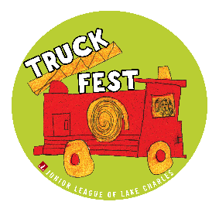Description: jl only

*Junior League of Lake Charles, Inc.*

*1019 Lakeshore Drive • Lake Charles, Louisiana 70601-9428*

*(337) 436-4025 • FAX (337) 436-4013*

[*WWW.JLLC.NET*](http://www.jllc.net)

**A member of The Association of Junior Leagues International Inc.**

The Junior League of Lake Charles is excited to announce the date of March 24,2018, for Truck Fest! Formally known as Touch A Truck, Truck Fest is a family- friendly event hosted by the Junior League of Lake Charles at Chennault International Airport from 9:00am to 3:00pm.

Children love to explore and investigate, and unrestricted play is essential for healthy, cognitive development. At Truck Fest, children and families will receive an exceptional hands-on experience, with vehicles of all types- construction, public service, emergency, utility, landscaping, transportation, delivery and more. Children will be able to interact with their favorite vehicles, learn about the importance of safety, and meet the men and women who serve and protect our communities. Those children who are sensitive to noise will enjoy Silent Hour from 9:00am to 10:00am. Kid friendly activities, face painting and delicious food will make this event a perfect family outing for the entire family!

As a Truck Fest exhibitor, you’ll have the opportunity to interact with parents, children, volunteers and the Lake Charles Community-at –large. Exhibitors are encouraged to support the Junior League of Lake Charles’ efforts by displaying their unique and exciting vehicles, machinery, boats and anything else children find fascinating.

Funds that raised through Truck Fest will support the Junior League of Lake Charles in its mission to promote voluntarism, develop the potential of women and improve communities through effective action and leadership of trained volunteers. The Junior League of Lake Charles is a 501(c)(3) organization and has served the Lake Charles community for more than 80 years. Truck Fest will allow the Junior League of Lake Charles to continue to enhance the quality of life in the areas of health, education and cultural development.

To become a Truck Fest exhibitor, please see the attached Sponsorship Opportunity and application. You can also email T[ruckfest@jllc.net](mailto:ruckfest@jllc.net). To learn more about The Junior League of Lake Charles, please visit [www.jllc.net](http://www.jllc.net). Thank you for your continued support.

Sincerely,

Kristi Cox and Christie Mundy

Truck Fest, Chair and Co-Chair 2018